Preparing OpenGL

The OpenGL is something new that I have never done before and that makes me excited about the process. In the beginning, it was kind of confusing since I follow the whole video provided by the professor but at the end, it wasn’t running. My first mistake was using OpenGLSample instead of OpenGL on the C:\ folder. Then I fix that and for some reason, it did not run on Apporto, so I decide to download Visual Studio and doing from the begging. After I did that, the code run perfectly.

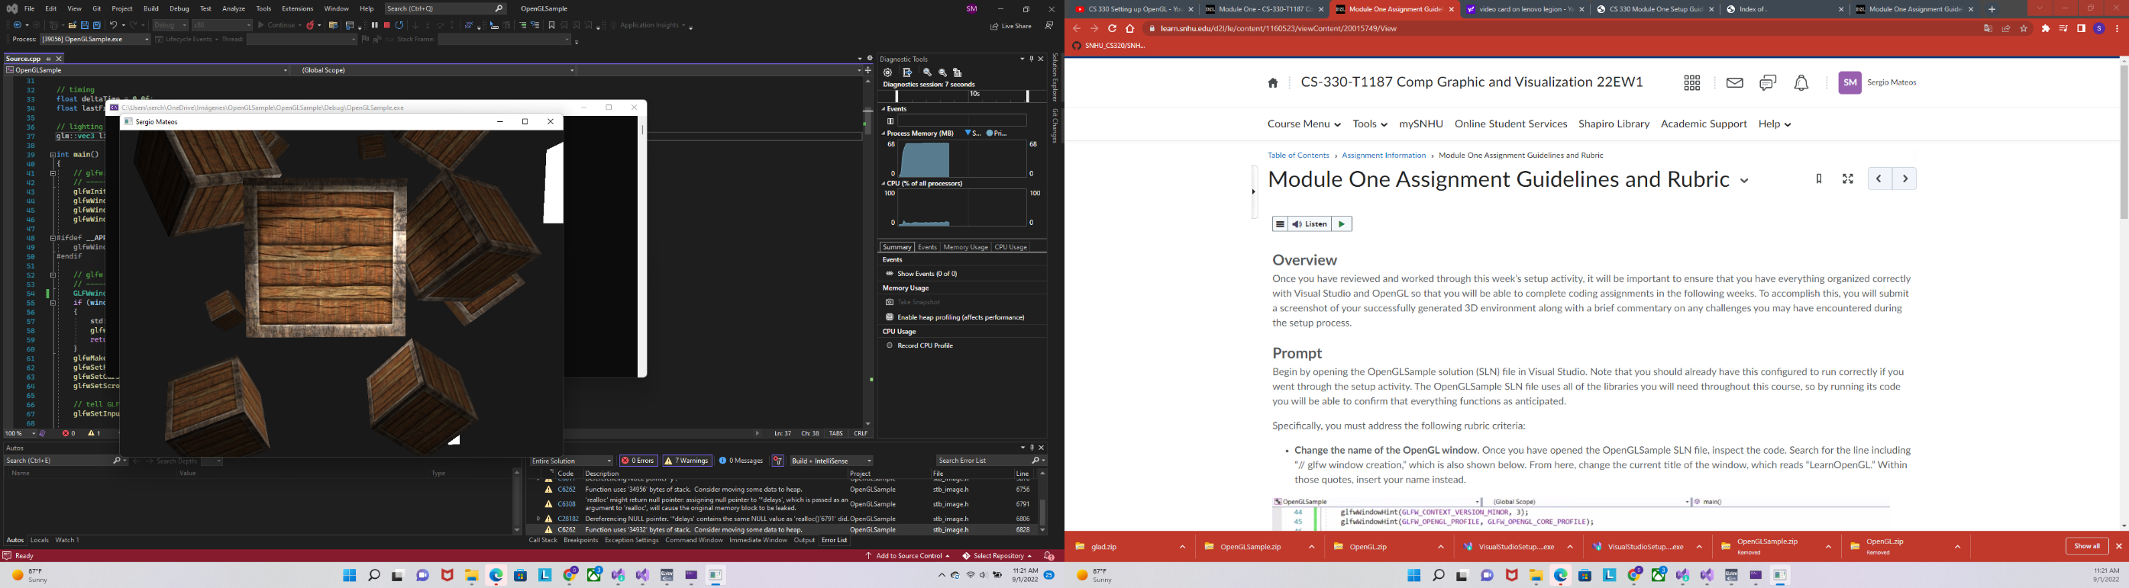 After reading thru on the set-up section I was able to change the name in the code, I think that part was easy, but I don’t know why even if is running perfectly, it keeps saying unauthorized access to the folder where OpneGLSample is at. It was an interesting experience but I was able to pass the challenge.